Group 2 Project
Melissa Dennis, Stephen Gombos, Kyle Beeden
2025-12-06
#rm(list = ls())
##Load libraries
library(readr)
## Warning: package 'readr' was built under R version 4.5.1
library(dplyr)
##
## Attaching package: 'dplyr'
## The following objects are masked from 'package:stats':
##
## filter, lag
## The following objects are masked from 'package:base':
##
## intersect, setdiff, setequal, union
library(janitor)
## Warning: package 'janitor' was built under R version 4.5.2
##
## Attaching package: 'janitor'
## The following objects are masked from 'package:stats':
##
## chisq.test, fisher.test
library(ggplot2)
library(cluster)
library(readxl)
## Warning: package 'readxl' was built under R version 4.5.1
library(tidyr)
library(factoextra)
## Warning: package 'factoextra' was built under R version 4.5.1
## Welcome! Want to learn more? See two factoextra-related books at https://goo.gl/ve3WBa
##Load data
raw_df <- read_excel("C:/Users/kylej/OneDrive/Documents/BA 64060/Final Project/EIA923_Schedules_2_3_4_5_M_12_2023_Final.xlsx")
## New names:
## • `` -> `...2`
## • `` -> `...3`
## • `` -> `...4`
## • `` -> `...5`
## • `` -> `...6`
## • `` -> `...7`
## • `` -> `...8`
## • `` -> `...9`
## • `` -> `...10`
## • `` -> `...11`
## • `` -> `...12`
## • `` -> `...13`
## • `` -> `...14`
## • `` -> `...15`
## • `` -> `...16`
## • `` -> `...17`
## • `` -> `...18`
## • `` -> `...19`
## • `` -> `...20`
## • `` -> `...21`
## • `` -> `...22`
## • `` -> `...23`
## • `` -> `...24`
## • `` -> `...25`
## • `` -> `...26`
## • `` -> `...27`
## • `` -> `...28`
## • `` -> `...29`
## • `` -> `...30`
## • `` -> `...31`
## • `` -> `...32`
## • `` -> `...33`
## • `` -> `...34`
## • `` -> `...35`
## • `` -> `...36`
## • `` -> `...37`
## • `` -> `...38`
## • `` -> `...39`
## • `` -> `...40`
## • `` -> `...41`
## • `` -> `...42`
## • `` -> `...43`
## • `` -> `...44`
## • `` -> `...45`
## • `` -> `...46`
## • `` -> `...47`
## • `` -> `...48`
## • `` -> `...49`
## • `` -> `...50`
## • `` -> `...51`
## • `` -> `...52`
## • `` -> `...53`
## • `` -> `...54`
## • `` -> `...55`
## • `` -> `...56`
## • `` -> `...57`
## • `` -> `...58`
## • `` -> `...59`
## • `` -> `...60`
## • `` -> `...61`
## • `` -> `...62`
## • `` -> `...63`
## • `` -> `...64`
## • `` -> `...65`
## • `` -> `...66`
## • `` -> `...67`
## • `` -> `...68`
## • `` -> `...69`
## • `` -> `...70`
## • `` -> `...71`
## • `` -> `...72`
## • `` -> `...73`
## • `` -> `...74`
## • `` -> `...75`
## • `` -> `...76`
## • `` -> `...77`
## • `` -> `...78`
## • `` -> `...79`
## • `` -> `...80`
## • `` -> `...81`
## • `` -> `...82`
## • `` -> `...83`
## • `` -> `...84`
## • `` -> `...85`
## • `` -> `...86`
## • `` -> `...87`
## • `` -> `...88`
## • `` -> `...89`
## • `` -> `...90`
## • `` -> `...91`
## • `` -> `...92`
## • `` -> `...93`
## • `` -> `...94`
## • `` -> `...95`
## • `` -> `...96`
## • `` -> `...97`
##Isolate the last 6 columns and remove the first 4 rows
data_raw <- raw_df[-(1:4),]
##Use the first row as the column names
colnames(data_raw) <- data_raw[1,]
##Remove first row as this is now a duplicate row
data_raw <- data_raw[-(1),]
##Clean column names for easier use
df_cleaned <- data_raw %>%
clean_names()
head(df_cleaned)
## # A tibble: 6 × 97
## plant_id combined_heat_and_power_pl…¹ nuclear_unit_id plant_name operator_name
## <chr> <chr> <chr> <chr> <chr>
## 1 1 Y . Sand Point Sand Point G…
## 2 1 N . Sand Point Sand Point G…
## 3 1 Y . Sand Point Sand Point G…
## 4 1 N . Sand Point Sand Point G…
## 5 2 N . Bankhead … Alabama Powe…
## 6 3 N . Barry Alabama Powe…
## # ℹ abbreviated name: ¹​combined_heat_and_power_plant
## # ℹ 92 more variables: operator_id <chr>, plant_state <chr>,
## # census_region <chr>, nerc_region <chr>, reserved <chr>, naics_code <chr>,
## # eia_sector_number <chr>, sector_name <chr>, reported_prime_mover <chr>,
## # reported_fuel_type_code <chr>, mer_fuel_type_code <chr>,
## # balancing_authority_code <chr>, respondent_frequency <chr>,
## # physical_unit_label <chr>, quantity_january <chr>, …
##Identify ID columns
id_vars <- c(
"plant_id",
"plant_name",
"plant_state",
"reported_fuel_type_code")
##Keep only columns listed in ID column vector, i.e., id_vars
df_ids <- df_cleaned %>%
select(any_of(id_vars))
##Grab YTD columns (last 6 columns of the data frame) as recommended in directions
ytd_raw <- df_cleaned %>%
select((ncol(.) - 5):ncol(.))
#See/check names of TYD columns
names(ytd_raw)
## [1] "total_fuel_consumption_quantity" "electric_fuel_consumption_quantity"
## [3] "total_fuel_consumption_mm_btu" "elec_fuel_consumption_mm_btu"
## [5] "net_generation_megawatthours" "year"
##Convert YTD columns to numeric
##Anything that cannot be converted will be turned to NA
ytd_numeric <- ytd_raw %>%
mutate(across(everything(), ~ as.numeric(as.character(.))))
##Check NA per column
na_prop <- sapply(ytd_numeric, function(x) mean(is.na(x)))
na_prop
## total_fuel_consumption_quantity electric_fuel_consumption_quantity
## 0 0
## total_fuel_consumption_mm_btu elec_fuel_consumption_mm_btu
## 0 0
## net_generation_megawatthours year
## 0 0
##Directions are to remove variables with significant missing value, however, the above shows that there are none to remove
##Combine df_ids and ytd_numeric
df_for_cluster <- bind_cols(df_ids, ytd_numeric)
##This step drops NAs
df_complete <- df_for_cluster %>%
tidyr::drop_na()
##See which rows were dropped for having NA value(s)
dropped_rows <- df_for_cluster %>%
filter(!complete.cases(.))
dropped_rows
## # A tibble: 1 × 10
## plant_id plant_name plant_state reported_fuel_type_code total_fuel_consumpti…¹
## <chr> <chr> <chr> <chr> <dbl>
## 1 8825 <NA> <NA> RFO 0
## # ℹ abbreviated name: ¹​total_fuel_consumption_quantity
## # ℹ 5 more variables: electric_fuel_consumption_quantity <dbl>,
## # total_fuel_consumption_mm_btu <dbl>, elec_fuel_consumption_mm_btu <dbl>,
## # net_generation_megawatthours <dbl>, year <dbl>
##Remove ID columns for clustering
clustering_data <- df_complete %>%
select(-plant_id, -plant_name, -plant_state, -reported_fuel_type_code, -year)
##Scale the numeric YTD columns
df_scaled <- scale(clustering_data)
##Determine Optimal Number of Clusters K
##Elbow Method to choose K. Look for a bend in the plot.
##Test k from 1 to 8.
set.seed(123)
k_max <- 8
##Calculate the Within-Cluster Sum of Squares for each K
wcss <- sapply(1:k_max, function(k){
kmeans(df_scaled, centers = k, nstart = 20, iter.max=100)$tot.withinss
})
##Visualize the Elbow Plot
elbow_plot <- data.frame(k = 1:k_max, wcss = wcss) %>%
ggplot(aes(x = k, y = wcss)) +
geom_line(color = "blue", linewidth = 1) +
geom_point(color = "blue", size = 3) +
labs(
title = "Elbow Method to Determine Optimal K",
x = "Number of Clusters (K)",
y = "Within-Cluster Sum of Squares (WCSS)"
) +
theme_minimal() +
theme(plot.title = element_text(hjust = 0.5, face = "bold"))
print(elbow_plot)
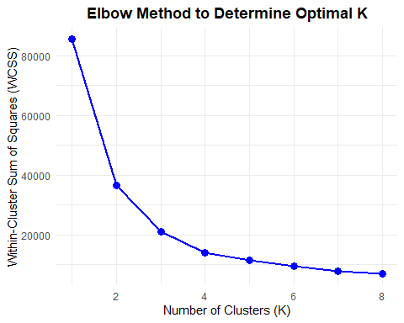
##Double Check: Use silhouette method to determine the number of clusters
fviz_nbclust(df_scaled, kmeans, method = "silhouette")
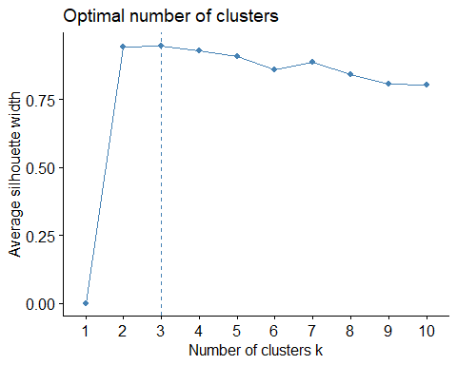
##Perform K-Means Clustering
##Based on the elbow plot, visually inspecting the bend 3 should be used for k.
K_FINAL <- 3
set.seed(123)
kmeans_result <- kmeans(df_scaled, centers = K_FINAL, nstart = 20)
##Attach the cluster assignment back to the original cleaned dataframe
df_clustered <- df_complete %>%
mutate(cluster = as.factor(kmeans_result$cluster))
df_clustered %>%
count(cluster)
## # A tibble: 3 × 2
## cluster n
## <fct> <int>
## 1 1 156
## 2 2 305
## 3 3 16643
##Summarize the key features by cluster to identify what makes them different
cluster_summary <- df_clustered %>%
group_by(cluster) %>%
summarise(
across(where(is.numeric), ~ mean(.x, na.rm = TRUE), .names = "avg_{.col}"),
most_common_fuel = names(which.max(table(reported_fuel_type_code))),
most_common_state = names(which.max(table(plant_state))),
n_plants = n(),
.groups = "drop"
)
cluster_summary
## # A tibble: 3 × 10
## cluster avg_total_fuel_consump…¹ avg_electric_fuel_co…² avg_total_fuel_consu…³
## <fct> <dbl> <dbl> <dbl>
## 1 1 1575617. 1569219. 82062108.
## 2 2 33539143. 30876384. 32506991.
## 3 3 355178. 278879. 759323.
## # ℹ abbreviated names: ¹​avg_total_fuel_consumption_quantity,
## # ²​avg_electric_fuel_consumption_quantity, ³​avg_total_fuel_consumption_mm_btu
## # ℹ 6 more variables: avg_elec_fuel_consumption_mm_btu <dbl>,
## # avg_net_generation_megawatthours <dbl>, avg_year <dbl>,
## # most_common_fuel <chr>, most_common_state <chr>, n_plants <int>
##Visualization for identifying outlines/problems
##Using Principal Component Analysis to reduce features down to 2 components so we can plot the clusters on a 2D graph.
pca_result <- prcomp(df_scaled, scale. = FALSE)
pca_data <- as.data.frame(pca_result$x) %>%
mutate(cluster = df_clustered$cluster)
##Plot the clusters using the first two principal components (PC1 and PC2)
cluster_plot <- pca_data %>%
ggplot(aes(x = PC1, y = PC2, color = cluster)) +
geom_point(alpha = 0.6) + # Plot all points
geom_point(data = filter(pca_data, cluster == cluster_summary$cluster[1]),
size = 4, shape = 1, color = "black") + # Highlight the smallest cluster (potential problem/outlier)
labs(
title = paste("Plant/Fuel Profiles Clustered (K=", K_FINAL, ")"),
subtitle = "Visualized using the first two Principal Components (PC1 and PC2)",
caption = "Smallest cluster is highlighted with a black border."
) +
scale_color_discrete(name = "Cluster") +
theme_minimal() +
theme(plot.title = element_text(hjust = 0.5, face = "bold"))
print(cluster_plot)
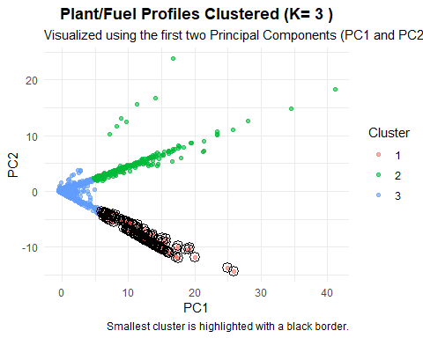
##Visualization - Cluster plot
fviz_cluster(kmeans_result, data = df_scaled,)
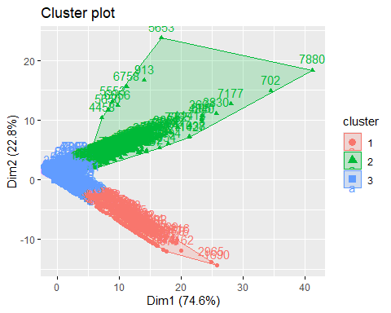
##Problem Identification
##The problem is likely found in the smallest cluster.
##This cluster contains observations that are statistically distinct from the rest of the data.
##Filter the original data to inspect the problematic/unique data points:
potential_problem_cluster <- cluster_summary %>%
arrange(n_plants) %>% # sort by size
slice(1) %>% # take the smallest
pull(cluster) # extract the cluster label
problem_data_points <- df_clustered %>%
filter(cluster == potential_problem_cluster) %>%
select(
plant_id,
plant_name,
plant_state,
reported_fuel_type_code,
net_generation_megawatthours,
total_fuel_consumption_quantity,
total_fuel_consumption_mm_btu,
cluster)
print(paste("--- Potential Problem/Anomaly Data Points (Cluster", potential_problem_cluster, ") ---"))
## [1] "--- Potential Problem/Anomaly Data Points (Cluster 1 ) ---"
print(problem_data_points)
## # A tibble: 156 × 8
## plant_id plant_name plant_state reported_fuel_type_c…¹ net_generation_megaw…²
## <chr> <chr> <chr> <chr> <dbl>
## 1 46 Browns Fe… AL NUC 9813139
## 2 46 Browns Fe… AL NUC 10256994
## 3 46 Browns Fe… AL NUC 10750377
## 4 130 Cross SC BIT 8418121.
## 5 204 Clinton P… IL NUC 8101628
## 6 210 Wolf Cree… KS NUC 10301865
## 7 298 Limestone TX SUB 6022030.
## 8 371 Columbia … WA NUC 8435018
## 9 470 Comanche … CO SUB 6637334.
## 10 566 Millstone CT NUC 5441282
## # ℹ 146 more rows
## # ℹ abbreviated names: ¹​reported_fuel_type_code, ²​net_generation_megawatthours
## # ℹ 3 more variables: total_fuel_consumption_quantity <dbl>,
## # total_fuel_consumption_mm_btu <dbl>, cluster <fct>

